MACH4METAL

metalworking machinery
Transito 21
6909 DA BABBERICH Netherlands
Tel. +31 (0)316-247123
Fax: +31 (0)316-247956
info@mach4metal.com
www.mach4metal.com

Bank No : 66.52.13.883
IBAN : NL33 INGB 0665 2138 83
BIC : INGBNL2A

SCHAEFER Profile bender SPVS 150
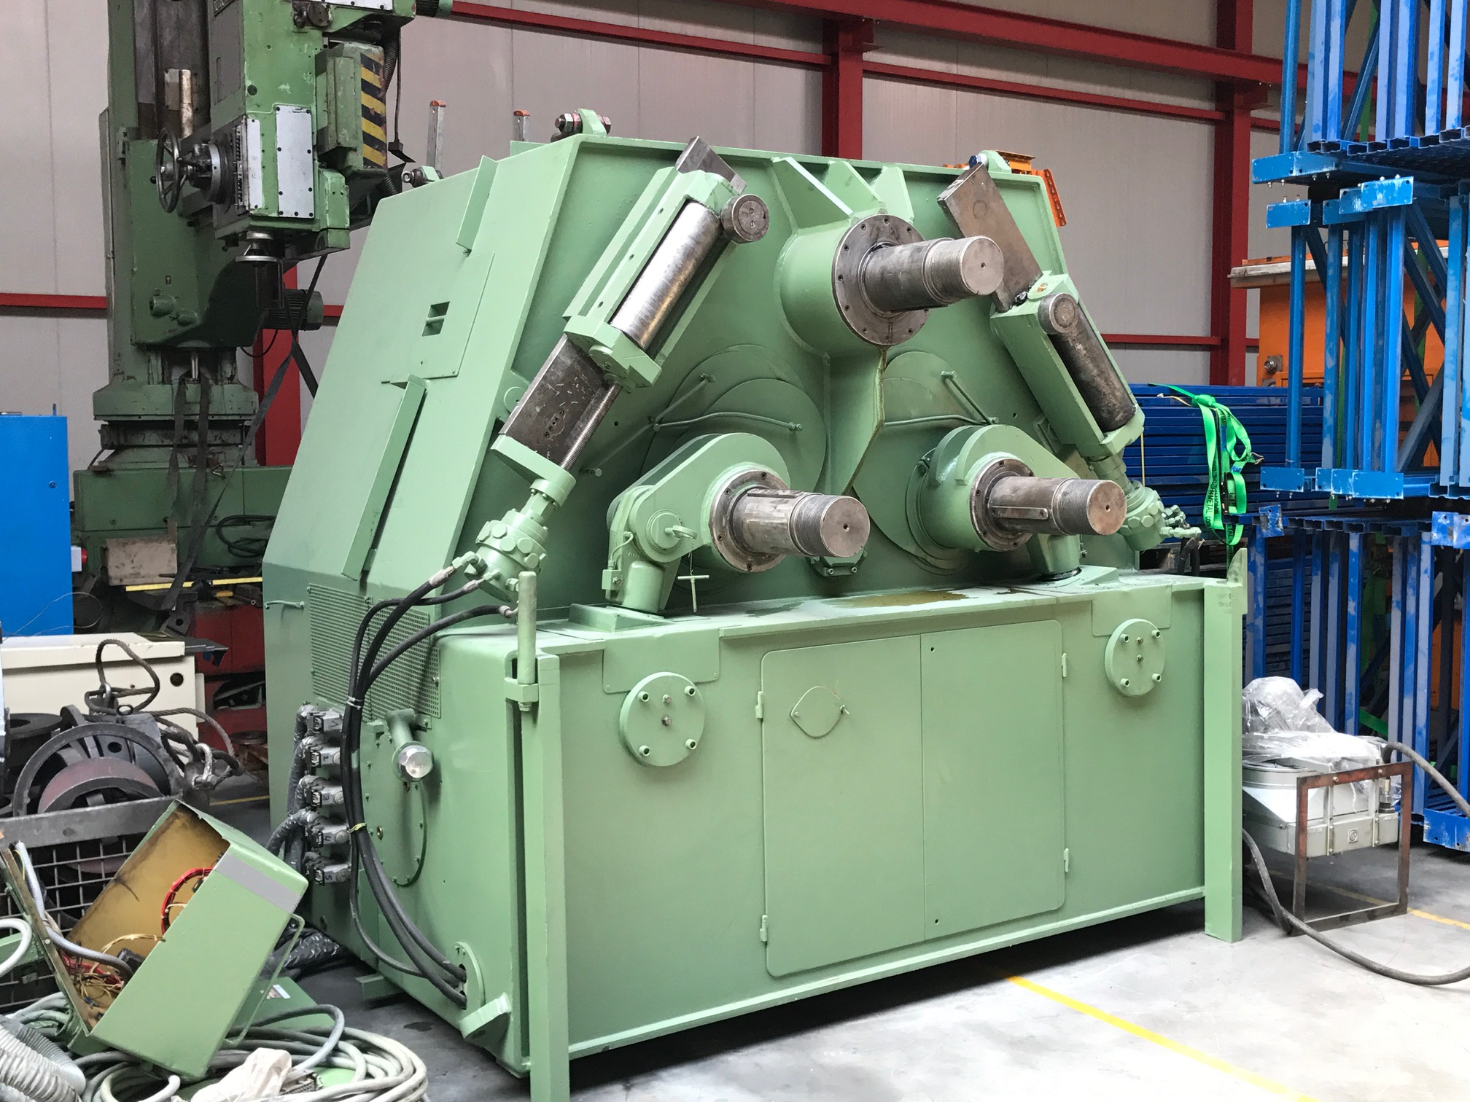
- Make : Schaefer Germany
- Typ : SPVS 90 / 150
- Serial No. : 5035 / 4121
- Age : 80 er

- Ø Shaft : 170
- Ø Roll : 470

- Adjustment roll : side rolls
- Stroke side roll : 300 mm
- Adj. speed : 0 – 250 mm/Min
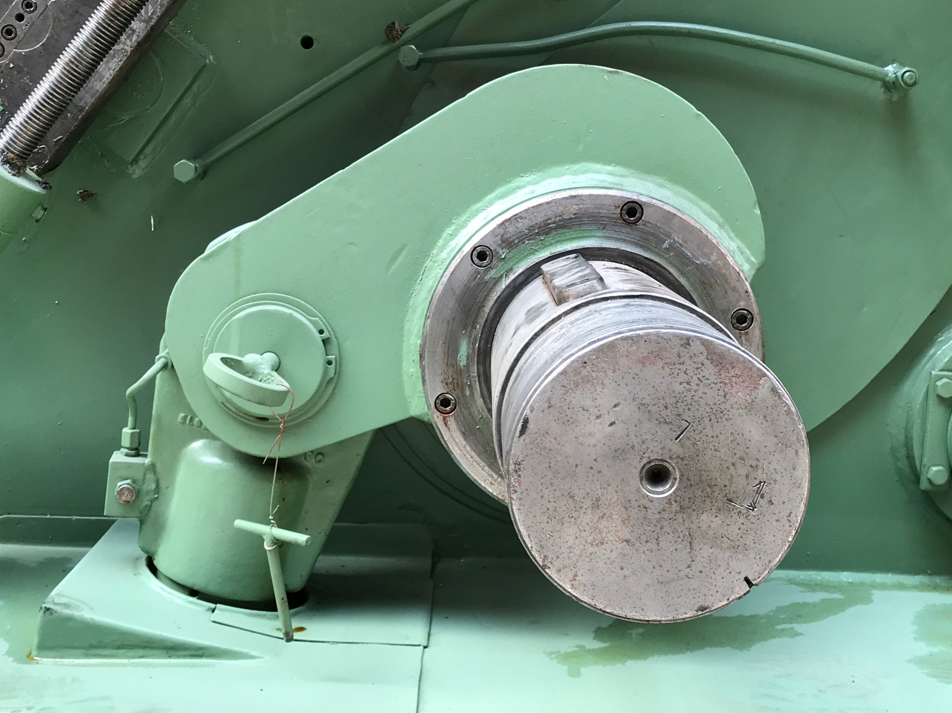
- Fully hydraulic
- Pump capacity 16 kW
- 3 rolls driven

- Bendning capacity
- Angle 150 x 150 x 16 Ø 1.500
- Angle 140 x 140 x 15 Ø 1.400
- T 120 x 120 x 14 Ø 1.200
- T 160 x 160 x 15 Ø 1.600
- Flat 150 x 25 Ø 1.500
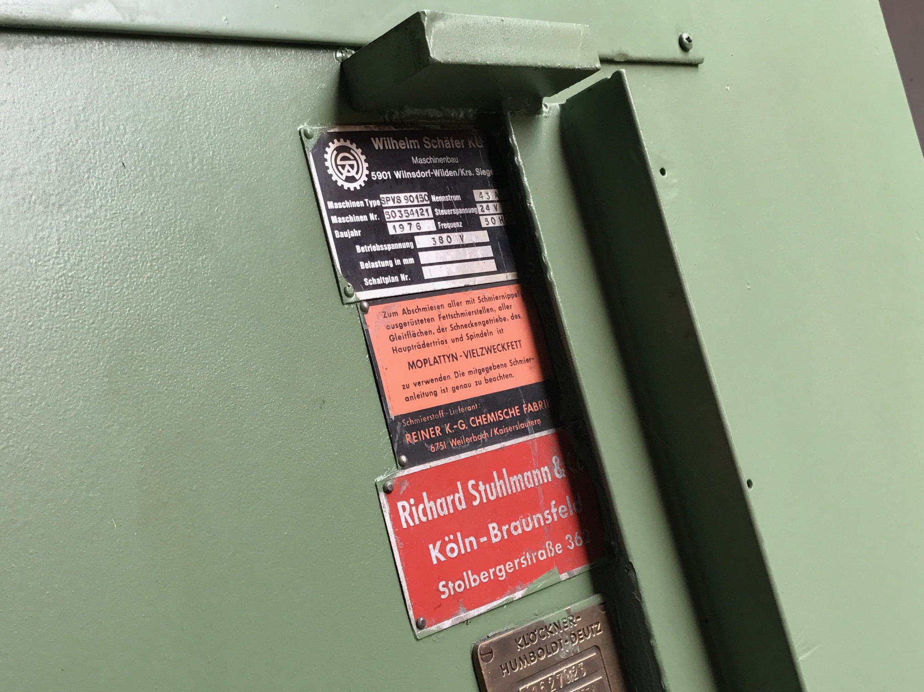
- Digital readout position side rolls
- Vario working speed 1 – 8 M/min
- Universal set rolls hardned

- Dimensions
- Length : 3.390
- Width : 3.415
- Height : 2.800

Please Note: The above information has been obtained to the best of our ability and belief from, and from the manufacturers where possible. It is given in good faith, but its accuracy can not be guaranteed. Accordingly, it will not form a representation or constitute contractual terms. We advise you to check any vital details!

